Email Capture User Guide

1. Go to System -> System Configuration

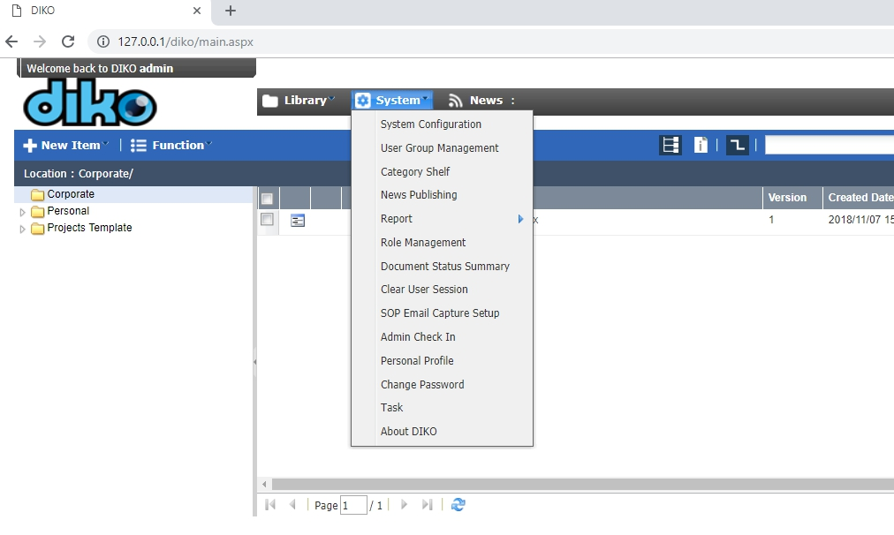

1. Under System Configuration, go to Capture Email Setting to set Email Capture settings

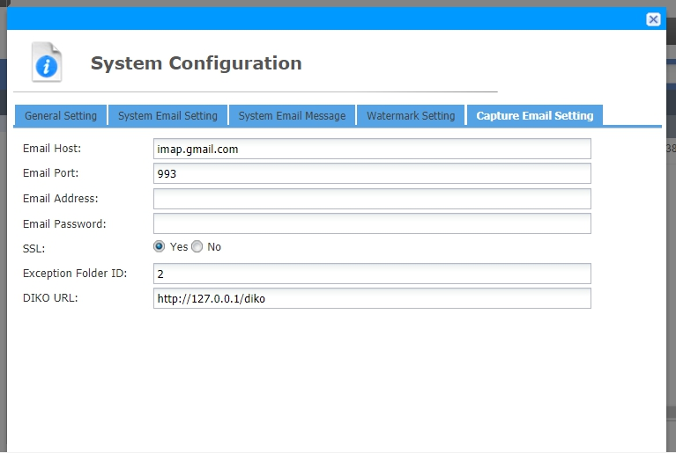

1. Input your **Receiving Email** Inbox information

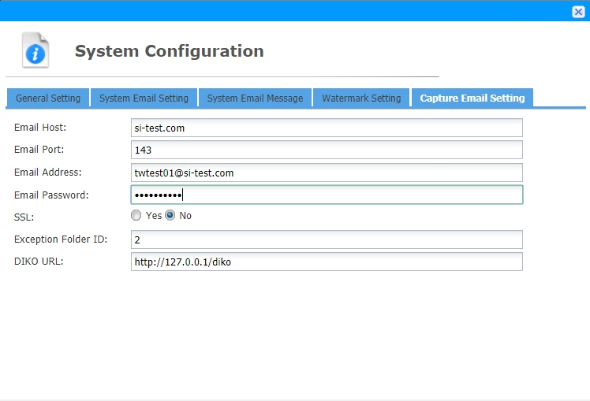

1. Scroll down and click “Save”

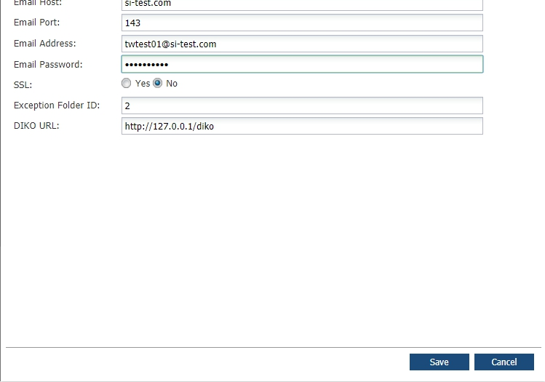

1. Go under System -> Personal Profile to set your account’s E-mail address -> Save

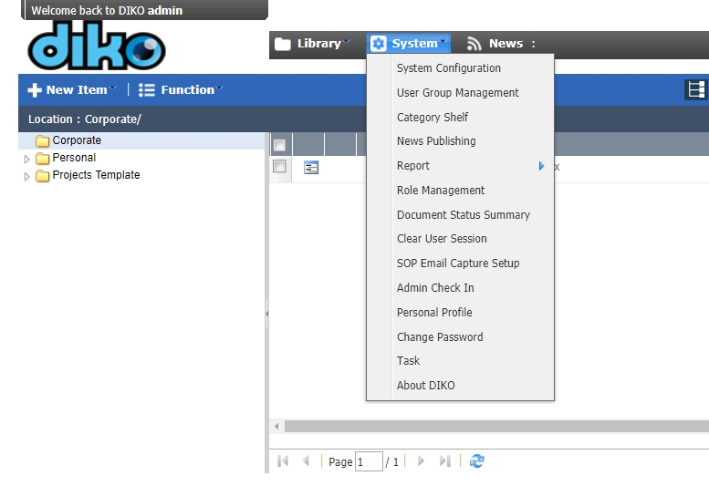

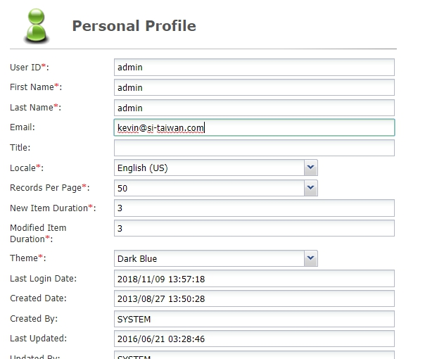

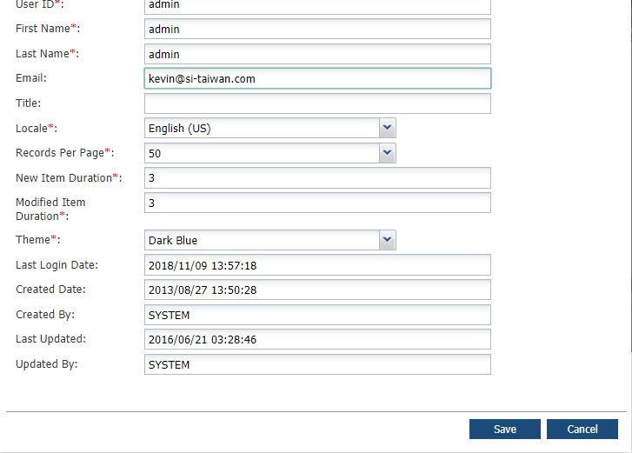

1. FROM any account’s E-mail address, send a mail to the Receiving E-mail Address to have the mail archived under your account’s Personal Folder (You can attach files and add message contents as well)

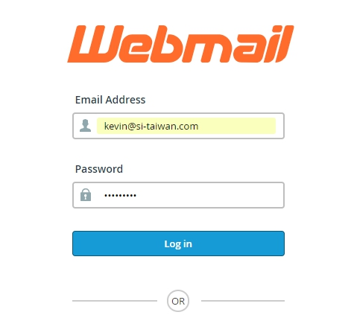

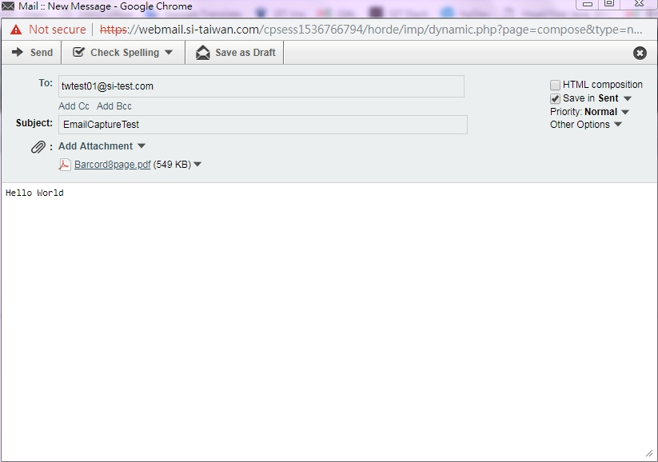

1. All mails sent from user email to receiving email([twtest01@si-test.com](mailto:twtest01@si-test.com)) will be archived under user’s Personal Folder, with the attachment, message and title all stored.

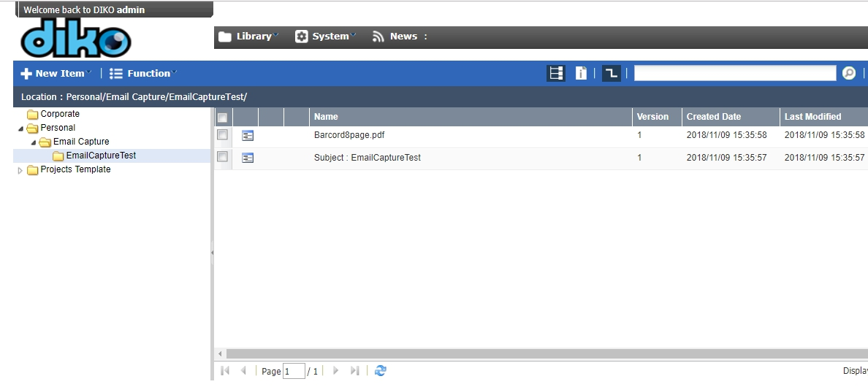

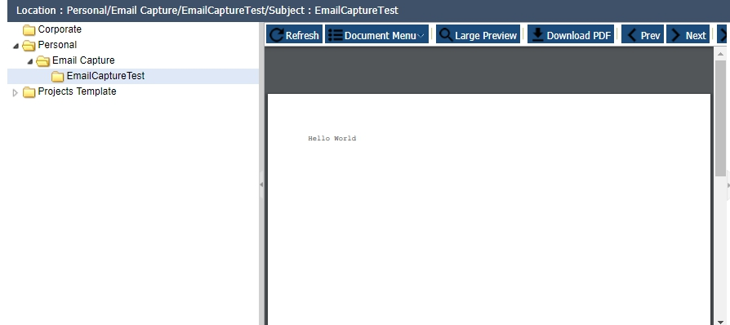

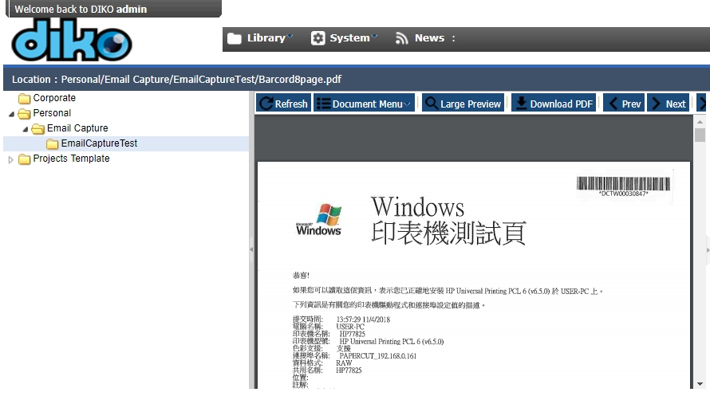

8. Note that Email Capture is designed to work well with MFP(Multi Function Printers) as users can scan from the printer and directly have the scanned documents be input and archived into DIKO's personal folder.